Project 4

ID：0811562 name：何祁恩

1. Source codes:

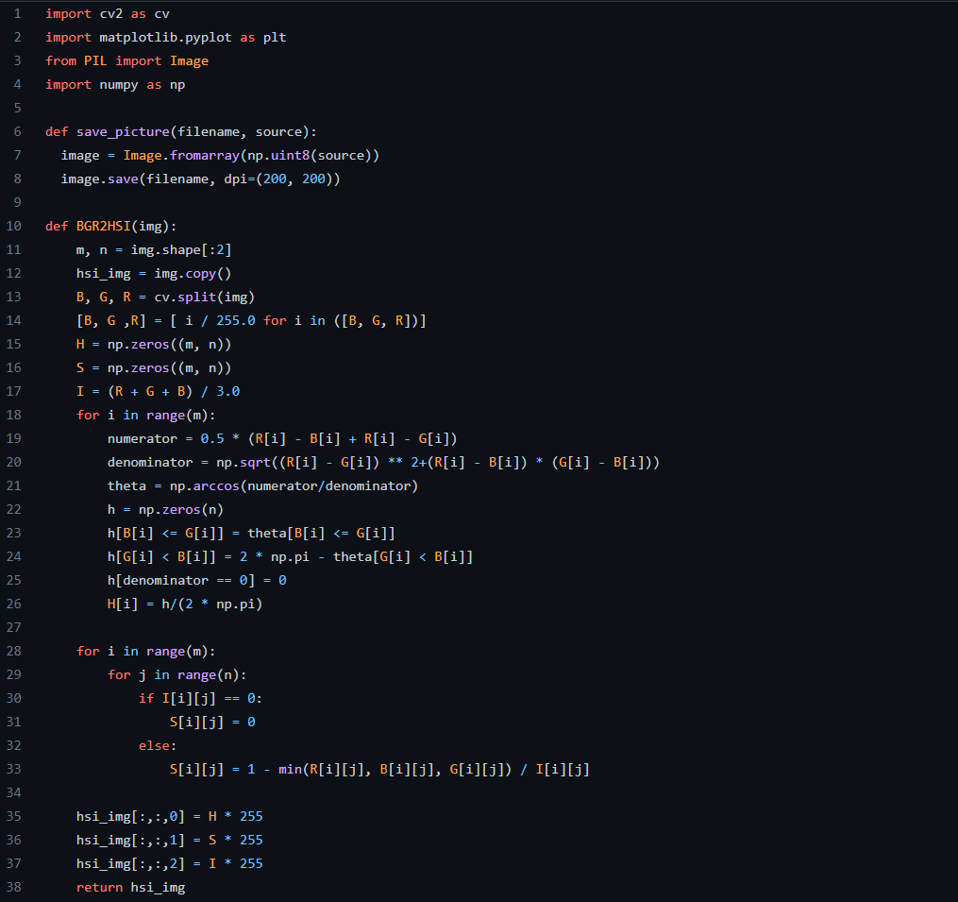

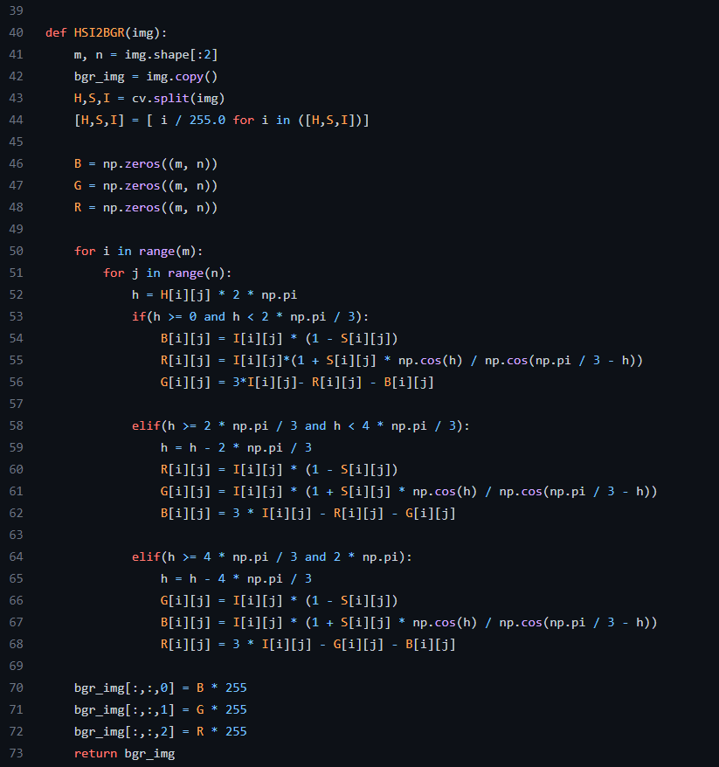

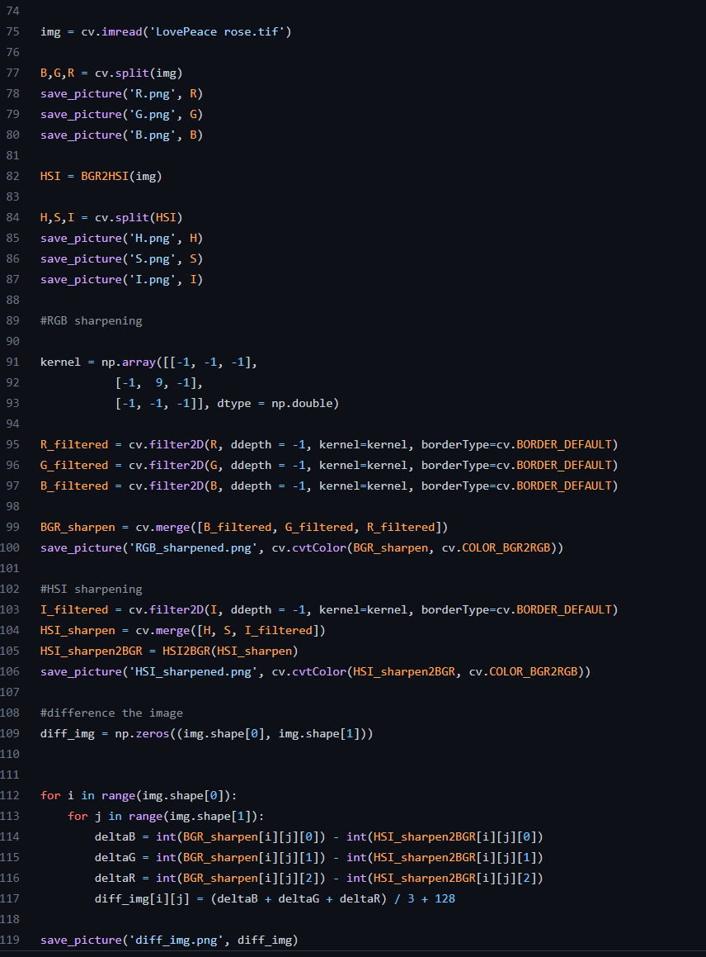

(b) Images of R, G, B, H, S and I component images:

|  |  |
| --- | --- |
| R | G |
| B | H |
| S | I |

(c) Output images enhanced by RGB-sharpening and HSI-sharpening scheme:

|  |  |
| --- | --- |
| RGB-sharpening | HSI-sharpening |

(d) Difference image of two images obtained in (c):

|  |
| --- |
|  |